TEXAS 4-H YOUTH DEVELOPMENT PROGRAM

DATE: December 7, 2020 - UPDATED

TO: All District 5 County Extension Agents

FROM: Jheri-Lynn McSwain, Ph.D.
District 5 4-H Extension Program Specialist

SUBJECT: 2021 District 5 4-H FCH Quiz Bowl Contest
April 10, 2021
Location to be determined if a face-to-face event is permitted
May be offered virtually

Due to recent COVID guidelines from AgriLife, the FCH Quiz Bowl committee has met and decided to move the contest date back into spring and to make this a senior age division only event. Please be sure to review the attached information and send the rules of play to your 4-H families.

Pages 1-2 is internal information for CEAs. Pages 3-7 should be copied and emailed/distributed to families desiring to participate in this contest. A marketing flyer is attached for your use. Be sure to add your county office contact information at the bottom.

District 5 Event Guidelines – Senior Age Division ONLY

Entry Requirements
  - Enter on 4HOnline beginning November 10, 2020 at https://texas4-h.tamu.edu/
  - Contest Fee - $10 per contestant
  - FCH Quiz Bowl is a team event (4-member team of the same age-division)
- Late Entry Fee - $25 per contestant

District Deadlines
  - Entry in 4HOnline by March 23, 2021
  - Soft due date for agents: March 24, 2021 (only to be used for corrections to entries)
  - Late entry – March 25-27, 2021 (late fees apply)

Entry Division (grade by August 31, 2020)
  - Senior Grades 9, 10, 11 and 12

Special Accommodations
- Any competitor who requires auxiliary aids or special accommodations must contact the District office at least 2 weeks before the competition or note such needs when registering on 4HOnline.

Entries Per County
  - Each county may submit three teams.
  - All team members must be in the senior age division.
- A total of 3 team entries per county may be submitted for the district contest.

Awards
- Quiz Bowl Awards will be given following tabulation of results.
  - 1st – 3rd place will be presented a rosette and an award to be determined by committee.
- Entry via 4HOnline gives permission to the District office to use the participant’s name and/or photograph, as needed for marketing and promotion purposes.

Agent Assignments
FCH Quiz Bowl
Chair: Arvitta Scott Claudann Jones Alyssa Kimbrough
Co-chair: Willie Arnwine Ryan Merrel Priya Nagireddy

Contest Committee Members/Judges (Face-to-Face format)
- Committee members will need to check-in by 8:30am. Members will receive a 4-H lanyard with their name to be worn during the day as an identifier for parents, contestants, and other agents. Please remit your lanyards at the end of your contest responsibility time for reuse.
- Orientation will begin promptly at 8:45am.

Parking
  - Signs will be posted on the doors to help guide you.

Questions Before Contest
- Contact Carolyn Walton, District 5 Administrative Assistant, at 903-834-6191 or via email at carolyn.walton@ag.tamu.edu

Questions at Contest
- Committee members will be present and can help provide directions.

2021 District 5 4-H fch quiz bowl
contest information
SPECIAL NOTE: We will adhere to Texas A&M AgriLife Extension Service COVID-19 social distancing guidelines in place at the time of this event. As of date of release the following guidelines will be followed:
- All contestants and anyone entering the building will be required to complete the COVID-19 screening form (see attached). You may download, complete, and bring to the event to expedite entrance to building or complete the form onsite.
- Wearing a face mask and social distancing of 6ft is required. There will be a designated area to space out our parents. This will allow proper social distancing. We will also have some chairs placed outside if the weather is permitting.
- Tables, chairs, and equipment utilized will be sanitized before, between teams utilizing, and after the event.

FCH Quiz Bowl Date
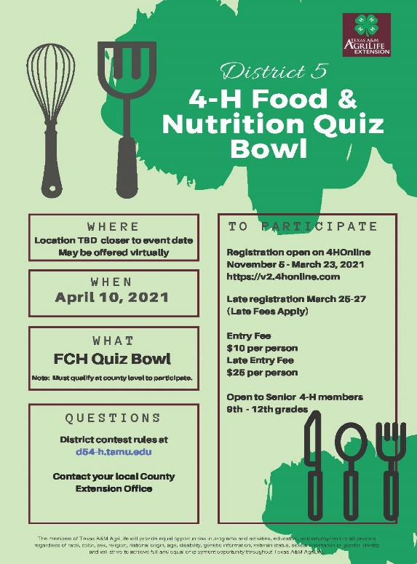
Saturday, April 10, 2021

Location
To be determined closer to contest date.
May be offered virtually.

Parking
  - Signs will be posted on the doors to help guide you.

Entry Requirements
  - Enter on 4HOnline beginning November 10, 2020 at https://texas4-h.tamu.edu/
  - Contest Fee - $10 per contestant
  - FCH Quiz Bowl is a team event (4-member team)
- Late Entry Fee - $25 per contestant

District Deadlines
  - Entry in 4HOnline by March 23, 2021
  - Late entry – March 25-27, 2021 (late fees apply)

Entry Divisions (grade by August 31, 2020)
  - Senior Grades 9, 10, 11 and 12

Special Accommodations
- Any competitor who requires auxiliary aids or special accommodations must contact the District office at least 2 weeks before the competition or note such needs when registering on 4HOnline.

Questions Before Contest
- Contact Carolyn Walton, District 5 Administrative Assistant, at 903-834-6191 or via email at carolyn.walton@ag.tamu.edu

Questions at Contest
- Please contact Committee Co-Chair arvitta.scott@ag.tamu.edu or text 281-222-2326.

Contest Schedule – To be determined

Awards – Face to Face format
- Quiz Bowl Awards will be given following tabulation of results.
  - 1st – 3rd place will be presented a rosette and an award to be determined by committee.
- Entry via 4HOnline gives permission to the District office to use the participant’s name and/or photograph, as needed for marketing and promotion purposes.
- We will only allow the parents of the teams to come in during each award presentation and then will ask them to leave so that we can present the next award. That will allow the least amount of people inside the contest room and will still give us the proper social distance that we need for everyone’s safety.

FCH Quiz Bowl (team event)
- Quiz Bowl Team Entries Per County
  - Each county may submit three teams per senior age division.
- A total of 3 team entries per county may be submitted for the district contest.

- Contest Brackets
  - Teams will be randomly selected in contest brackets, based upon age division.
  - Each contest is a double elimination tournament where a total of two losses are needed to eliminate a team from further competition.

- Question Types
  - The number of questions used per round will include at least eight (8) one-on-one questions, sixteen (16) toss-up questions, and two (2) to four (4) bonus questions.
    - One-on-One questions are those to which only one member or each team may respond in a head-to-head match between the acknowledged members of each team. These points will count toward individual and team scores.
    - Toss-up questions are open to response by all contestants. These points will count toward individual and team scores.
    - Bonus questions are attached to toss-up questions and are given to the team that correctly answered the toss-up question. These points count toward a team score only and do NOT count towards individual points. No more than 25% of toss-up questions will have a bonus question attached and in general will be somewhat more difficult.

- Electronic Devices
  - No electronic devices or jewelry (except for medically required) is allowed in contest area. This includes cell phones, smart watches, or other communication devices.
- Contest Room
  - ONLY THE TEAM and ONE coach is allowed in the contest room. All others must remain 6ft apart in the designated waiting areas or outside the building.
  - Masks are required; however, once the contestants sit down for the contest, we will allow them to take their masks off. They will also be 6 feet apart as well to comply with social distancing standards.
  - Team coach will be seated in a designated area and may not communicate with team members during the match with the exception of their one time out.
  - Team coach will be permitted one 1-minute time out during their match to provide encouragement to contestants.
  - Teams must check-in and check-out of the contest room.

- Reference Materials
- All questions used in the quiz bowl contest will come from official sources. See the study guide and list of resources used on the web at https://texas4-h.tamu.edu/projects/food-nutrition/.

- Show Rankings
  - Placings will be announced following the contest.
  - 4-H FCH Quiz Bowl scorecards, comments and other correspondence will be forwarded to the contestant’s county Extension office. Please allow up to three weeks for processing
- Qualifying for State FCH Quiz Bowl Roundup
  - Senior age division contestants (grades 9-12) which place 1st – 3rd at the District-level FCH Quiz Bowl contest will advance to state.
  - The Texas 4-H Quiz Bowl contestant paperwork is available online at
https://texas4-h.tamu.edu/projects/food-nutrition/

COVID-19 Screening Form
Due to the COVID-19 pandemic, and in an attempt to minimize the spread of the virus, Texas A&M AgriLife Extension Service is required to screen all youth, staff, and visitors participating in a youth day or overnight event. In order to be granted access to events, all visitors must truthfully complete and submit the following:

I, _ _, hereby affirm that:

- While at the event I will maintain a minimum of 6 feet of separation from any other individuals not within my household.
- I have not in the past 7 days exhibited any of the known symptoms of COVID-19, including:
  - Cough
  - Shortness of breath or difficulty breathing
  - Chills
  - Repeated shaking with chills
  - Unexpected muscle pain
  - Headache
  - Sore throat
  - Loss of taste or smell
  - Diarrhea
  - Running a fever (or measuring a temperature of 100.0 degrees Fahrenheit or more)
- In the past 14 days I have not been in contact with any person known to have contracted COVID-19.

I understand face coverings (over the nose and mouth), or non-medical grade face masks are required per the Governor’s Resolution GA-29 on July 2, 2020. I also understand that it is recommended that I follow the minimum standard health protocols issued by the Texas Department of State Health Services and cited by the Texas Governor in his Executive Orders related to the pandemic.

I understand that the virus that causes COVID-19 can be spread to others by infected persons who have few or no symptoms. Even if an infected person is only mildly ill, the people they spread it to may become seriously ill or even die, especially if that person is 65 or older with pre-existing health conditions that place them at higher risk. Because of the hidden nature of this threat, everyone should rigorously follow the practices specified in the DSHS protocols, all of which facilitate a safe and measured reopening of Texas. The virus that causes COVID-19 is still circulating in our communities. We should continue to observe practices that protect everyone, including those who are most vulnerable.

I understand that AgriLife Extension cannot guarantee that I will not contract the virus, even when implementing screening protocols. I further understand that safety is a shared duty, COVID-19 is a shared risk, and all community members, including visitors, must take steps to promote health and safety. I acknowledge that I am assuming the risk that I may contract the virus by entering facilities, even when screening protocols and mitigation measures are implemented.

I understand that AgriLife Extension is required to have this attestation in order for me to attend events sponsored by them and I sign below to confirm the truth of the above.

Printed Name of Participant Date

Street Address, City, State, Zip Code Cell Phone Number

Signature (or legal guardian if minor) Email

