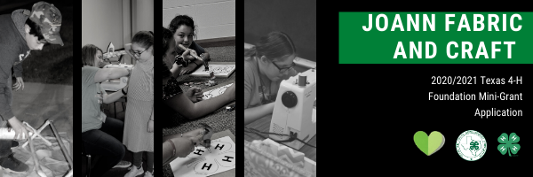

Joann is helping 4-H bring more hands-on programs to local communities across the nation to inspire kids to lead lives with their hearts, hands, and minds. The Clovers for Kids campaign monies are now available to Texas 4-H clubs, project groups, and county 4-H programs through a mini-grant program. Mini-grants are designed to help build and support 4-H Fashion and Interior Design project work. The maximum amount per mini grant is $250.

Guidelines for applying:
- Application must be for the support of a 4-H Club, group, or service project in Texas.
- Funds must be used for building or supporting a 4-H Fashion and Interior Design Project
Examples of such include:
  - Purchasing equipment and/or supplies for a community service project
  - Purchasing supplies for a Fashion & Interior Design workshop
  - Pay for group tour expenses
  - Purchase sewing machines for county program
- Funds cannot be used for:
  - Personal gain or use
- The application must be completed online at https://fs4.formsite.com/state4h/0npk2dqju3/index.html
- Deadline for application January 15th, 2021 at 5pm.

The members of Texas A&M AgriLife will provide equal opportunities in programs and activities, education, and employment to all persons regardless of race, color, sex, religion, national origin, age, disability, genetic information, veteran status, sexual orientation, or gender identity and will strive to achieve full and equal employment opportunity throughout Texas A&M AgriLife.

Grant Application Worksheet
(This worksheet is provided to assist applicants in completing the online process. The application must be completed online at https://fs4.formsite.com/state4h/0npk2dqju3/index.html )

Please complete the application fully and make sure it is submitted by selecting the submit button at the bottom of application screen. Only complete submitted applications will be reviewed.

Name of Person Submitting Application:
County:
4-H Club/Group/County Name:
Is this Club Chartered: | YES/NO
Mailing Address of Person Applying:
City, State, Zip of Person Applying:
Phone Number of Person Applying:
Email of Person Applying:
County Extension Agent’s Name:
County Extension Agent’s Email:
Name of project for which funds are requested:

On the following questions please provide as much detail as possible about the need for funding.

Funding request amount: | $
Provide a budget for the funds requested.
Based on the funds requested, provide a detailed narrative of project activities to take place.

What is the timeline for your Fashion and Interior Design project?
What will be the impact on the participants?
What is the estimated number of individuals that will participate in this project?

APPLICATION CERTIFICATION:

- I, the submitter, agree these funds will be used to support Fashion and Interior Design project work and/or community service as detailed in this application. I further agree to provide all the necessary reports, photographs and /or financial records requested at any time for the funds provided.

- I, the submitter, agree that no funds requested will be used for personal gain or private/ commercial use by myself, any of our club youth or adults.

