A Label Able Valentine’s Day
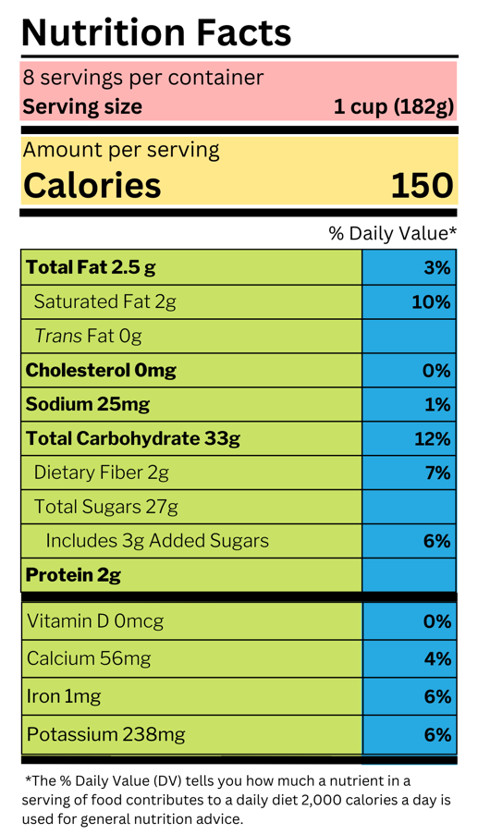
As Valentine’s Day approaches during American Heart Health month, there are often many labels used when giving (and receiving) a box of chocolates, flowers, or jewelry. While relationship labels can easily be the plot line of a romantic comedies, understanding the nutrition facts label on food can be downright confusing.

The nutrition facts label is a tool that helps us make informed decisions about our food and beverage choices. The label breaks down the number of calories, carbs, fat, fiber, protein, and vitamins per serving of the food, making it easier to compare the nutrition of similar products.

Pink Section: Look at the number of servings in the package (servings per container) and the serving size. Serving sizes are listed in familiar units, such as cups or pieces. The information below the serving size (calories, fat, etc.) will refer to one serving.

Yellow Section: Calories listed are a measure of energy in one serving of the food item. Calorie recommendations vary depending on your age, gender, height, weight, and physical activity level. A general recommendation is 2,000 calories a day. To learn more about your estimated calorie needs visit the MyPlate Plan at https://www.myplate.gov/.

Green Section: Nutrients and the amount of each nutrient are listed here. Generally, a healthy eating pattern includes nutrients from a variety of fruits, vegetables, low-fat dairy, lean protein, whole grains, and limited amounts of saturated fats, added sugars, and sodium.

Blue Section: The Percent Daily Value (DV) shows how much a nutrient in one serving contributes to a total daily diet. You can use the DV to see if an item is low or high in a specific nutrient. Note, the DV is not to be added vertically. Thanks to the DV we do not have to do the calculations with the numbers from the green section. A DV at or below 5% is considered a low source of the specific nutrient listed for one serving while a DV at or higher than 20% is considered a high source. You can learn more here https://youtu.be/s5zroZfMn0I.

Celebrate this month by learning more about how to use, read, and better understand the nutrition facts label.

Written and Photo by: Lindsey Breunig-Rodriguez, Project Specialist – Better Living for Texans
Source: https://www.fda.gov/food/new-nutrition-facts-label/how-understand-and-use-nutrition-facts-label
Local Events

All month: Heart Health Month
February 11: Food Distribution at St. William’s

Upcoming Events for March
National Nutrition Month all month
Food Distribution at St. William’s- 3/11 6:30 am-10 am
Be Well Live Well begins (info in newsletter)

Recipe of the Month
Recipe from MyPlate Kitchen at MyPlate.gov (photo from Canva.com)

Baked Parmesan Fish
Celebrate American Heart Month and Valentine’s Day with this parmesan-crusted fish (a lean protein) topped with mushrooms, green onions, and garlic.
Serves: 4

Ingredients:
¹/₃ | cup low-fat grated parmesan cheese
1 | teaspoon flour
1 | teaspoon fresh thyme sprigs  (or ¼ teaspoon dried thyme)
4 | (6-ounce) white fish fillets (tilapia, cod, catfish)
2 | teaspoons oil
1 | medium onion, chopped
1 | cup mushrooms, chopped
¹/₂ | cup green onions, finely sliced
1 | clove garlic, crushed
 | ground black pepper (to taste)
 | squeeze of lemon (optional)

Directions:
- Preheat oven to 350°F. Mix cheese, flour, and thyme in a bag or bowl. Individually coat each fish with the cheese mixture; discard leftover mixture. Place fish on a baking sheet and bake for 20 minutes or until fish flakes easily when tested with a fork.
- Heat skillet over medium-high heat. Add oil, onion, mushrooms, green onions, and garlic. Cook, stirring frequently, until onions are tender. Season with ground black pepper.
- Serve baked fish topped with mushroom mixture and a fresh squeeze of lemon.

Nutrients Per Serving:
204 calories, 2 g total fat, 0 g saturated fat, 122 mg cholesterol, 227 mg sodium,
8 g carbohydrates, 1 g fiber, 2 g total sugar, 0 g added sugar, and 37 g protein

Total Cost: $$$$

