Pick Your Produce… Fresh, Frozen, or Canned!
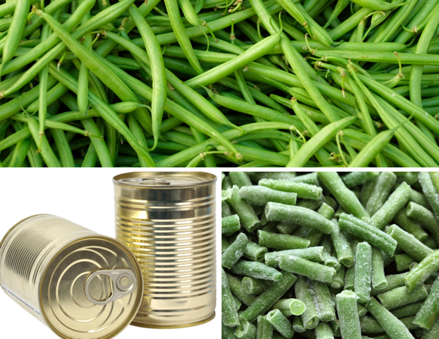
Did you know fruits and vegetables can be enjoyed in a variety of ways? When comparing the nutritional value of fresh, frozen, and canned produce, research continues to show that each form COUNTS toward a healthy diet or eating pattern! Choosing fresh, frozen, and canned fruits and vegetables increases how many options there are at the store and can help save time and money when shopping. Let’s talk about shopping tips for each!

Sometimes fresh fruits and vegetables are not widely available and can cost more depending on the season and where you live. Additionally, some fresh produce travels very far to our stores and can lose nutrients in transit and potentially spoil quicker. To extend the shelf-life of fruits and vegetables, freezing or canning options are available. In processing/preserving fruits and vegetables, the produce is picked at its peak freshness in both flavor and nutrients and then processed accordingly. During processing, some fruits and vegetables lose nutrients, when compared to fresh produce but the change is minimal. Equally, there are some fruits or vegetables with more nutrients available when frozen or canned as fresh items begin to lose nutrients once picked. Again, these differences are minor and vary between different fruits and vegetables!

When shopping, compare prices and consider other factors such as convenience and time. For a quick dinner, heating up a can of green beans will save time versus preparing fresh green beans; yet fresh baby carrots may be preferred for school lunches compared to canned carrots. Look for products with “no added salt” and “no added sugar.” These ingredients may be added during processing. However, if you buy canned vegetables with salt added, you can remove extra salt by rinsing vegetables under cool running water in a colander. Doing so can decrease the sodium content by 25-40%!

Pick what is best for you and your family while maximizing your food budget. Remember, all fresh, frozen, or canned produce counts!

Written by: Heidi Fowler, RD, LD – Texas A&M AgriLife Extension Service
Content Source: Have a Plant: About the Buzz: Frozen and Canned Fruit and Vegetables VS Fresh
Photo From: Canva

Local Events

St William Food Outreach program, May 13

Recipe of the Month

Recipe Adapted from Natalie Monson, RD, CD, Super Healthy Kids

Fruit Pizza

Keep a variety of fresh, frozen, and canned fruits and vegetables on hand. The different options may keep you interested in eating a serving at every meal.
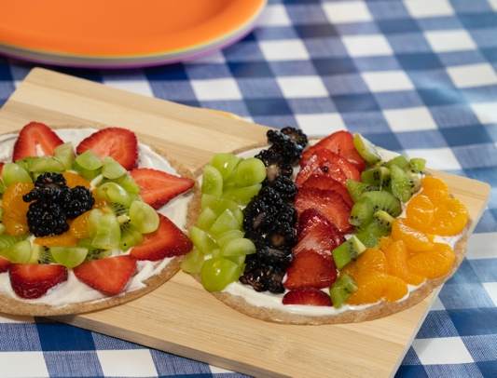
Ingredients |  | Toppings
½ | cup low-fat Greek yogurt, plain | ¼ | cup strawberries
1 | teaspoon honey | ¼ | cup kiwi
½ | teaspoon vanilla extract | ¼ | cup green grapes
1 | tablespoon orange juice | ¼ | cup blackberries
6 | medium tortillas, whole wheat | ¼ | cup mandarin oranges, canned in juice

Directions
- In a small mixing bowl, blend together yogurt, honey, vanilla extract, and orange juice until fully blended.
- Slice strawberries; peel kiwi, cut in half and slice; cut grapes into quarters; slice blackberries;
and drain oranges.
- Heat a skillet to lightly toast tortillas on both sides for 1 to 2 minutes. Let cool.
- Spread yogurt mixture onto tortillas and top with fruit.

Nutrients Per Serving: 160 calories, 2 g total fat, 1 g saturated fat, 0 mg cholesterol, 150 mg sodium,
30 g carbohydrates, 1 g fiber, 8 g total sugar, 1 g added sugar, and 6 g protein.

Total Cost: $$$$

